**3BM3U1 Shapes （4.26）讲义**

1. **-ff [ f ] turn off take off**
2. **能够正确朗读以下内容，并理清逻辑关系——冷了要关电风扇，亮了要关灯，热了要脱外套**

**Turn off the fan. We are cold.**

**Turn off the light. It is bright.**

**Take off the coat. It is so hot.**

1. 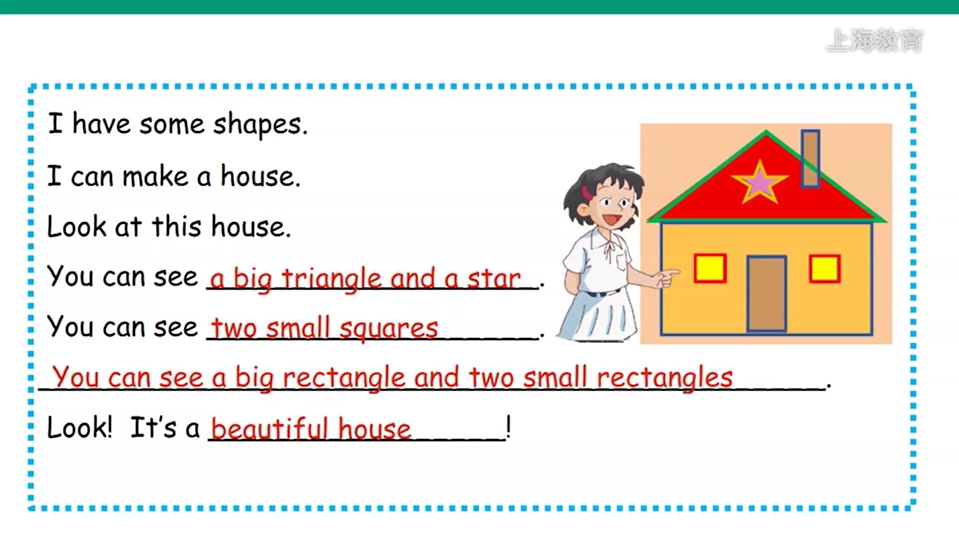**能够较流利地介绍自己用形状搭建的房子，注意形状的单复数**

1. **A triangle is like a tree. 形状是可数名词，单数前面一定要加a，所以这里是a triangle。另外be动词+like解释为像...**
2. **A circle is like a ball. 形状是可数名词，单数前面一定要加a，所以这里是a circle。另外be动词+like解释为像...**
3. **能够正确认读图片，并清楚句型结构A + 形状 + is like + a + 物品. 意思是某个形状像某一样东西。**

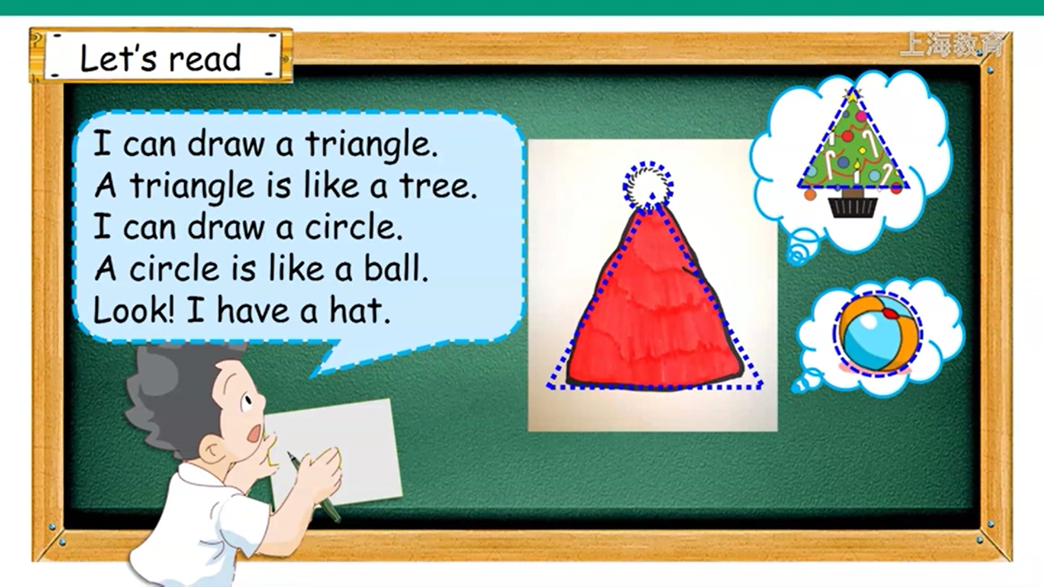

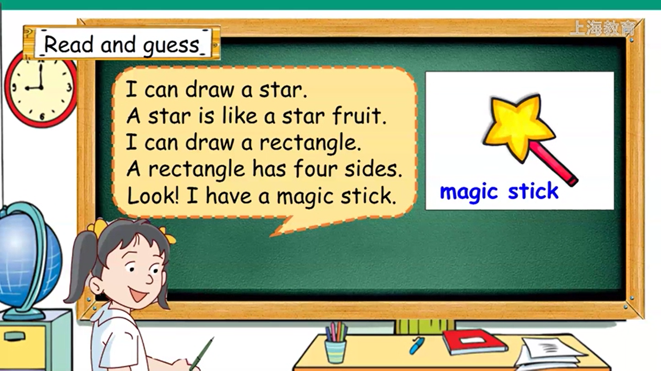

**这里的side，解释为边**

**magic stick = magic wand, 解释为魔法棒**

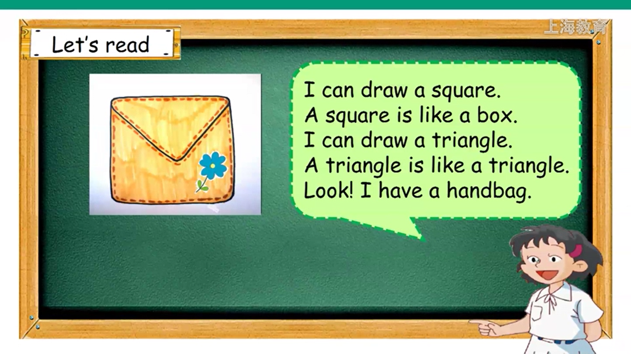

**handbag，解释为手提包**

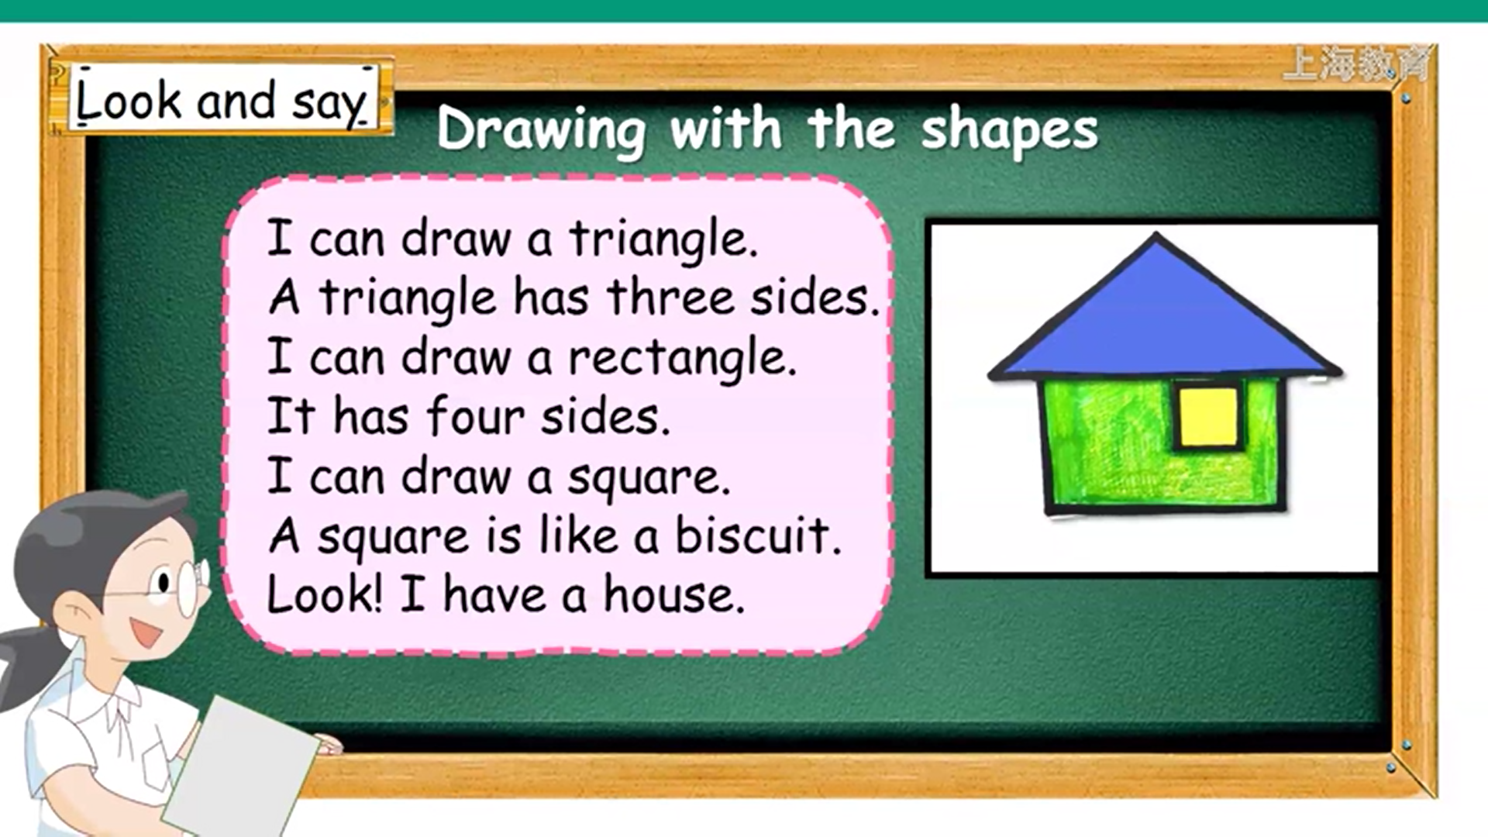

**这里用has, 因为主语a triangle和it都是第三人称单数**

1. **能够正确朗读书本P29的Listen and enjoy，观察be动词+like以及has的用法**

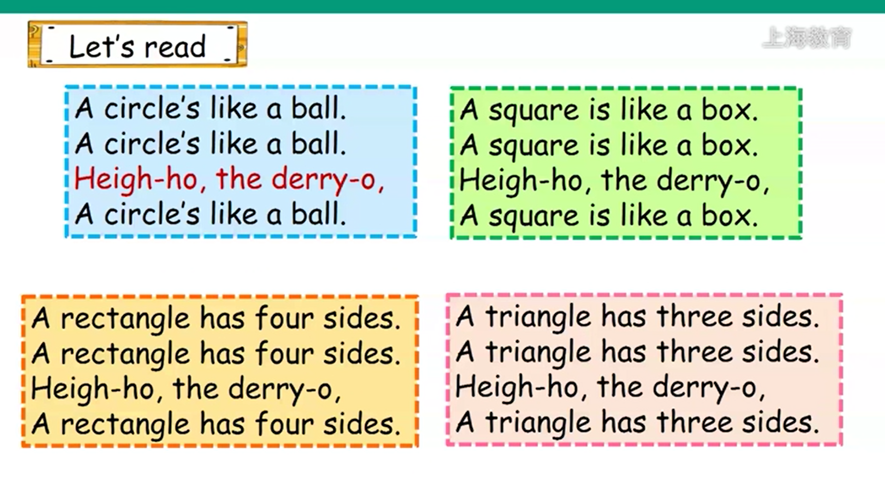

1. **能够对自己的简笔画进行形状描述(画的东西至少2种形状)**

**I can draw a ____(shape). A ____(shape) is like a ____(thing).**

**I can draw a ____(shape). A ____(shape) is like a ____(thing).**

**……**

**Look! I have a ____(what you draw).**

**3BM3U1 Shapes （4.26）知识点**

## 一、单词、词组：

|  |  |  |  |  |
| --- | --- | --- | --- | --- |
| count  数... | picture  图片 | eight  8 | three  3 | two  2 |
| red  红色的 | blue  蓝色的 | brown  棕色的 | yellow  黄色的 | long  长的 |

**二、句子：(注意大小写、标点符号、单词之间空出一个字母的距离)**

1. What shape is the box, Alice? Alice, 这个盒子是什么形状的？
2. It’s a square. 它是一个正方形。
3. Look at the ruler. What shape is it? 看看这把尺，它是什么形状的？
4. It’s a rectangle. 它是一个长方形。
5. Look at the picture. How many triangles? 看看这张图片，里面有几个三角形？
6. Eight triangles. 有八个三角形。

## 三、语法看点

1. How many...?

How many...?不管回答有几个，问句必须是 How many 后紧跟可数名词的复数，当然名词复数之前可以加一些形容词，比如 How many big balls? How many long rulers?

How many 的答句可以是简单的只有数字，注意只有数字的话，数字首字母要大写，后面要有句号， 比如说 How many books? One！也可以是数字后面+名词，注意单复数。也可以是 There is one. / There are two/ three...

还有问--How many ....s can you see? 回答I can see + 数字 + 东西.

--How many ...s do you have? 回答I have + 数字 + 东西.

1. What shape is it? It’s a...

What shape is it?意思是它是什么形状的，答句一定要注意这里的形状都是可数名词，所以前面要+a!

It’s a circle/ a square/ a triangle/ a star/ a rectangle.

1. What is it? 它是什么东西？ What shape is it? 它是什么形状的？

如果指着一本书，问 What is it?回答 It's a book. 问 What shape is it?回答 It's a rectangle.

如果指着一张三角形的纸，问 What is it?回答 It's a piece of paper. 问 What shape is it?回答 It's a triangle.

**3BM3U1 Shapes （4.26）随心练**

**一．听录音，选出合适的应答句**

|  |  |  |
| --- | --- | --- |
| **1.( ) A. It’s triangle.** | **B. Yes, it is.** | **C. It's a triangle.** |
| **2.( ) A. I can see three.** | **B. I have three.** | **C. There are three.** |
| **3.( ) A. It's circle.** | **B. It's a square.** | **C. It’s a biscuit.** |

1. **听录音，写出你所听到的单词**

|  |  |
| --- | --- |
| **1. --What ________ is it? --It’s a ________.** | **2. --Look at the ________. How many ________? --Sorry, I can’t see.** |

**三．正确抄写下列句子**

**look sally what shape is your new bag its a circle**

|  |
| --- |
|  |
|  |
|  |

**四．判断发音是否一致**

|  |  |  |  |
| --- | --- | --- | --- |
| **1.( ) picture triangle** | **2.( ) shape make** | **3.( ) box hot** | **4.( ) off of** |

**五．读句子，写出合适的单词，首字母已给**

|  |
| --- |
| **1. Look at the t________. It’s like a r________.** |
| 1. **--What shape is your r________? --It’s a s________.** |
| 1. **--What c________ is your dog? --M________ dog is white.** |

**六．按要求改写句子**

|  |  |
| --- | --- |
| 1. **I have some shapes.(否定句)** | **_______ _______ _______ _______ _______.** |
| 1. **My ruler is a rectangle.(划线部分提问)** | **_______ _______ _______ _______ _______?** |
| 1. **I can see a big circle. (划线部分提问)** | **_______ _______ _______ _______ _______**  **_______ _______?** |